NAME: Diptadeep Ghosh Roll No: CSE /23/080 Exam Roll No: 11600223051
Assignment No-4: Create a Public Bucket in AWS. Upload a file and give the necessary permission to check whether the file URL is working.
Goal: To create a public Amazon S3 bucket, upload a file, and configure permissions
to verify public access using a file URL.

Solution:
Step 1: Open S3 service
- Login to AWS Management console.
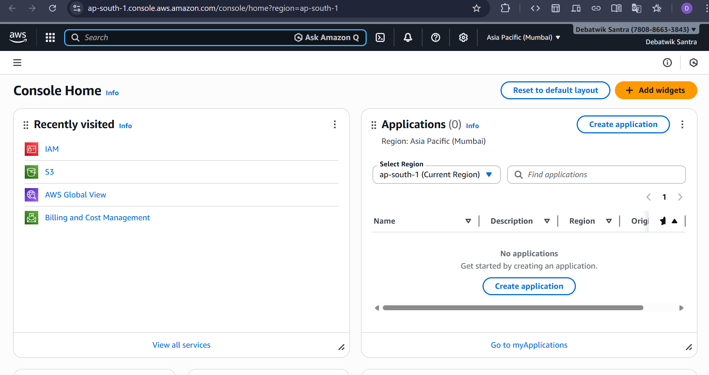
- Search S3 in the top Search bar.
- Click S3.
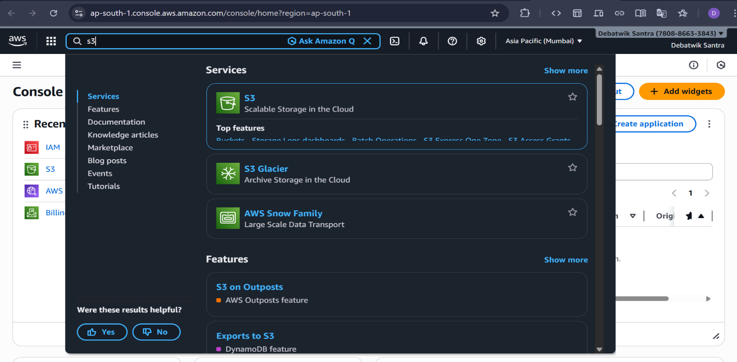
Step 2: Create S3 Bucket
- Click Create bucket.
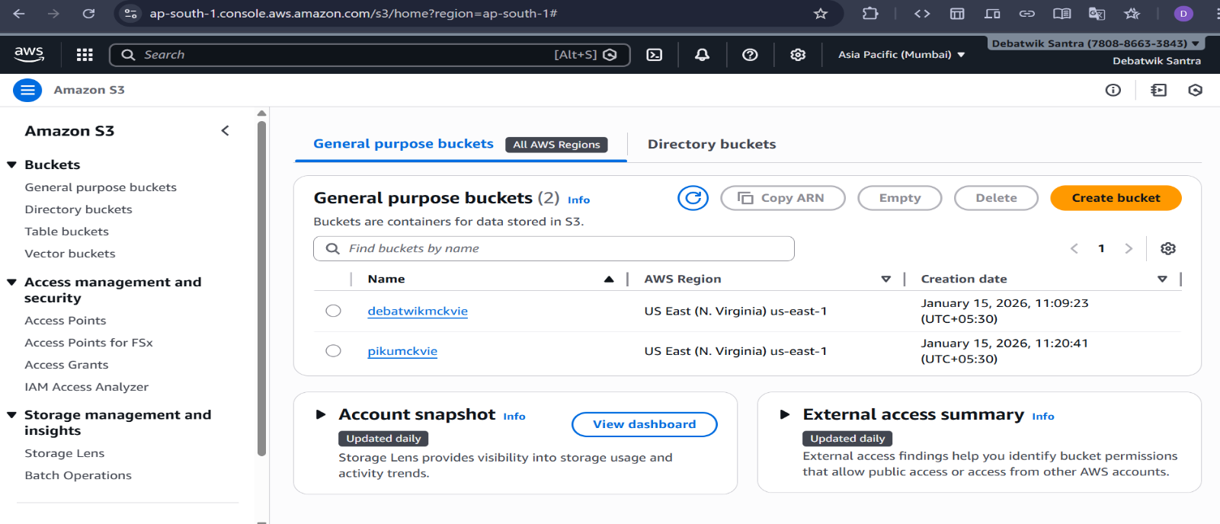
- Set the following details:
- AWS Region: Asia Pacific (Mumbai) ap- South-1.
- Bucket type: General Purpose
- Bucket name: my – public-bucket-Debatwik
(Bucket name must be globally unique)
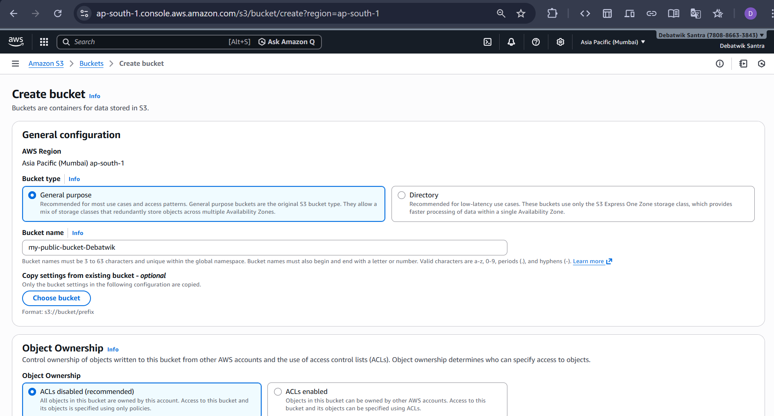
- Under Object Ownership:
- Select ACLs enabled.
- Choose Buckets owner preferred.

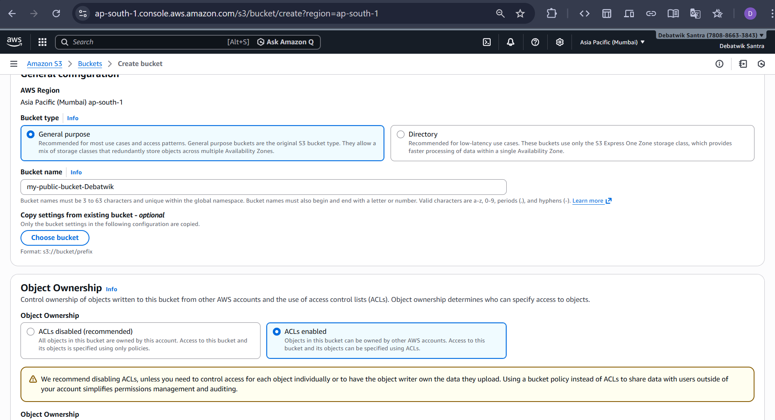

- Now, uncheck the box for “block all public access”. All individual boxes are automatically unchecked. At the bottom of the window, check the box confirming that the current setting changes may result in a public bucket.
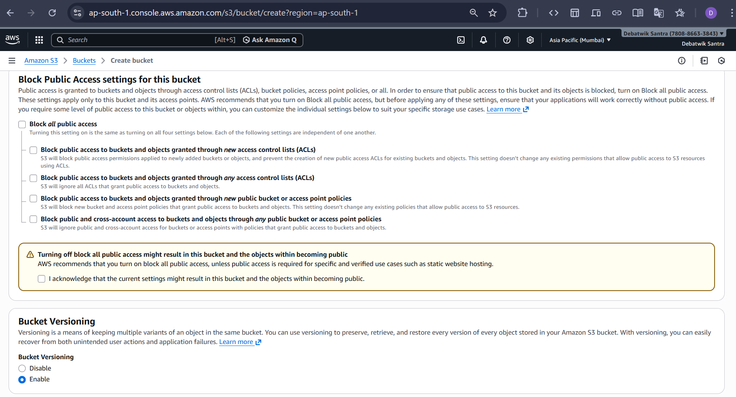
- Under Bucket Versioning: Select Enable and Also Leave the Tags as default(optional). And Click on the Create Bucket.

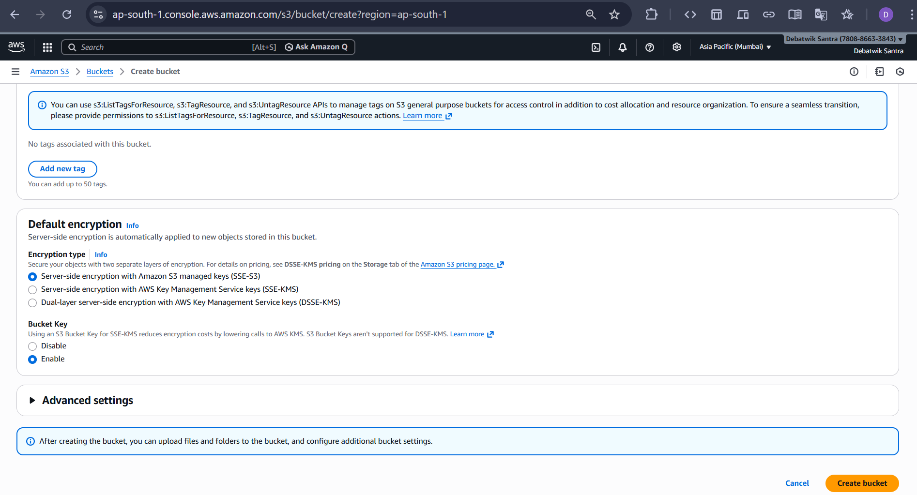
Step 3 : Upload File to Bucket
- Open the Recently Created bucket by clicking on it.
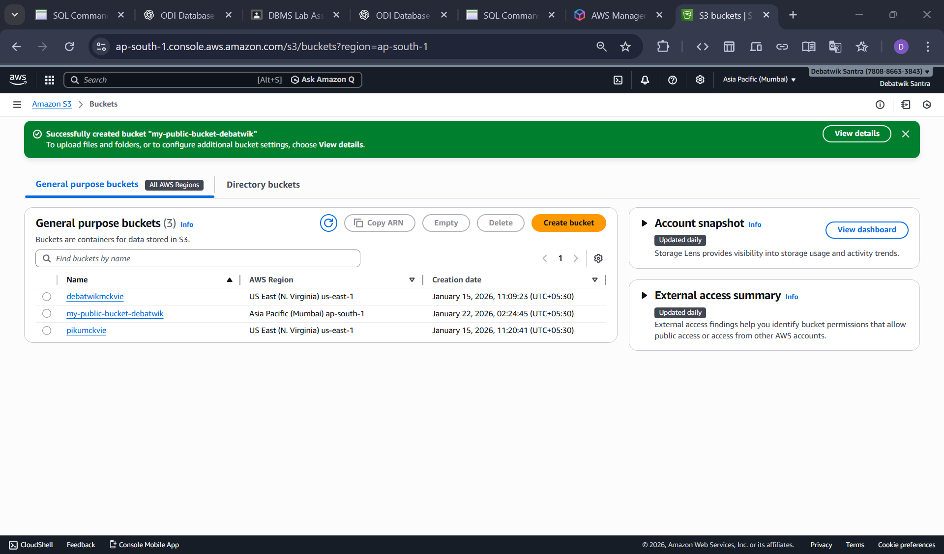
- Click on Upload.
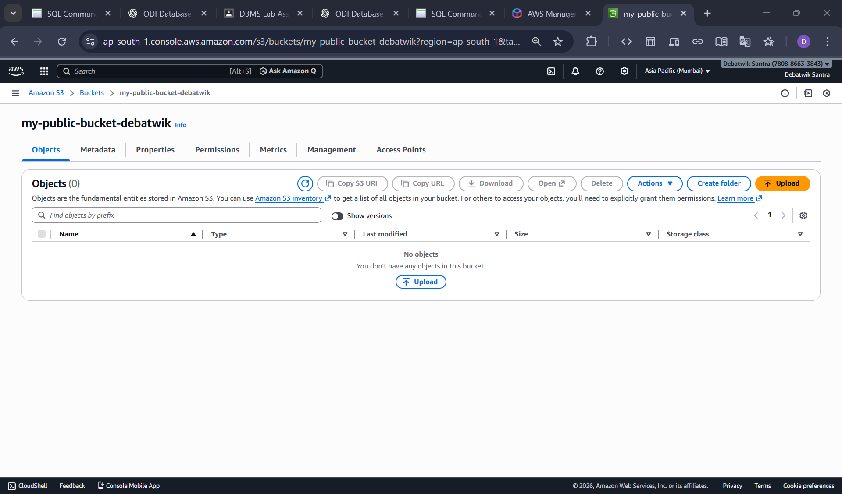
- Click on the Add files and Select any file (any .txt or .jpg file).
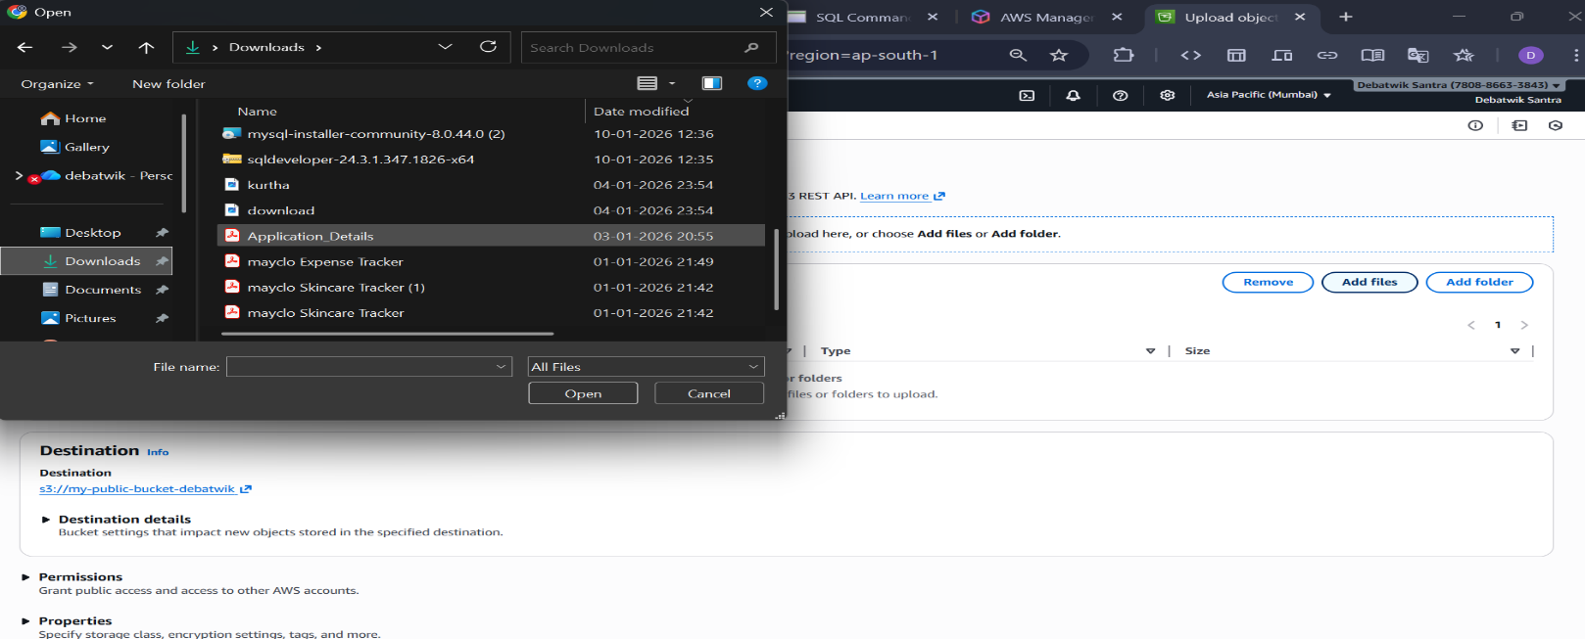
- Click on Upload
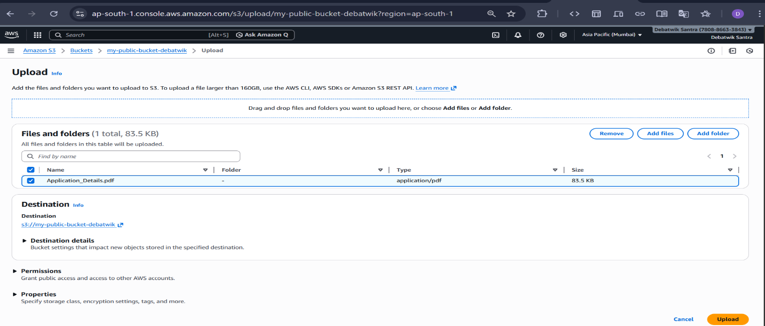
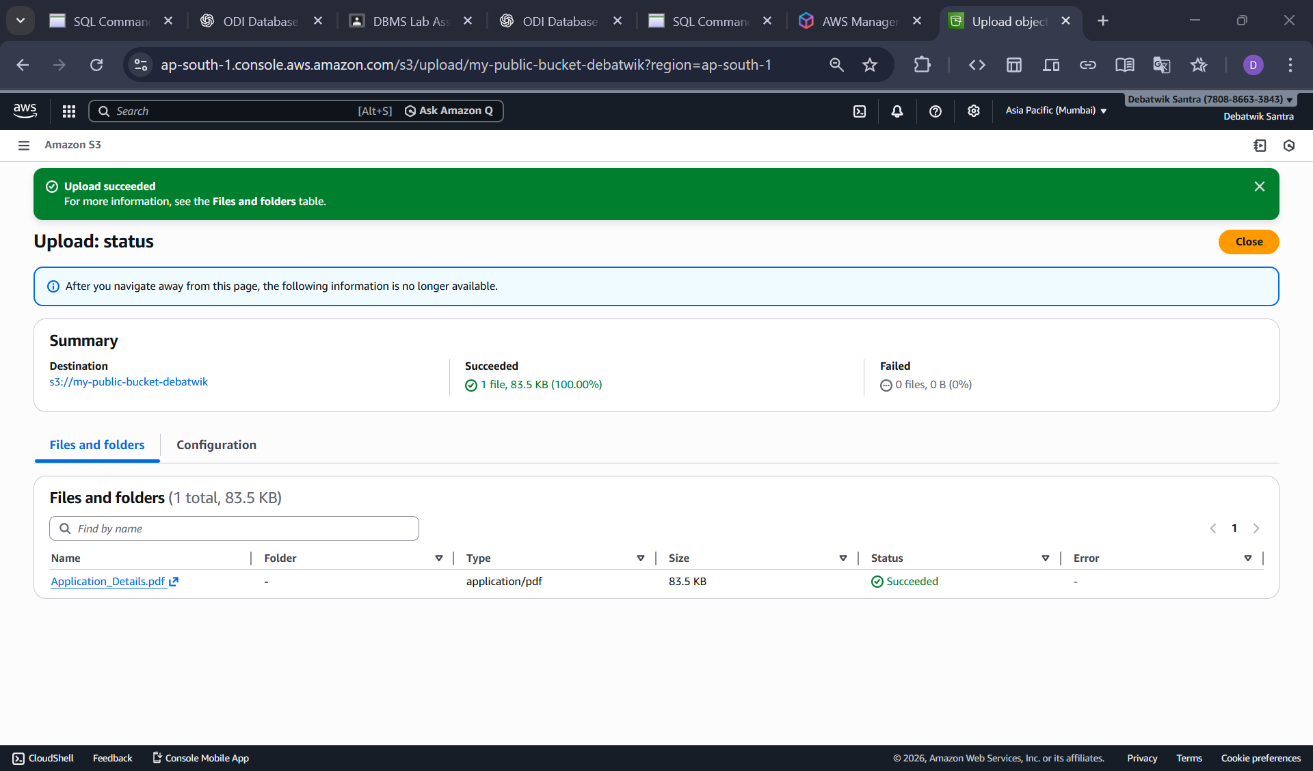
- Now, click on one of the uploaded file, then “Copy URL”.
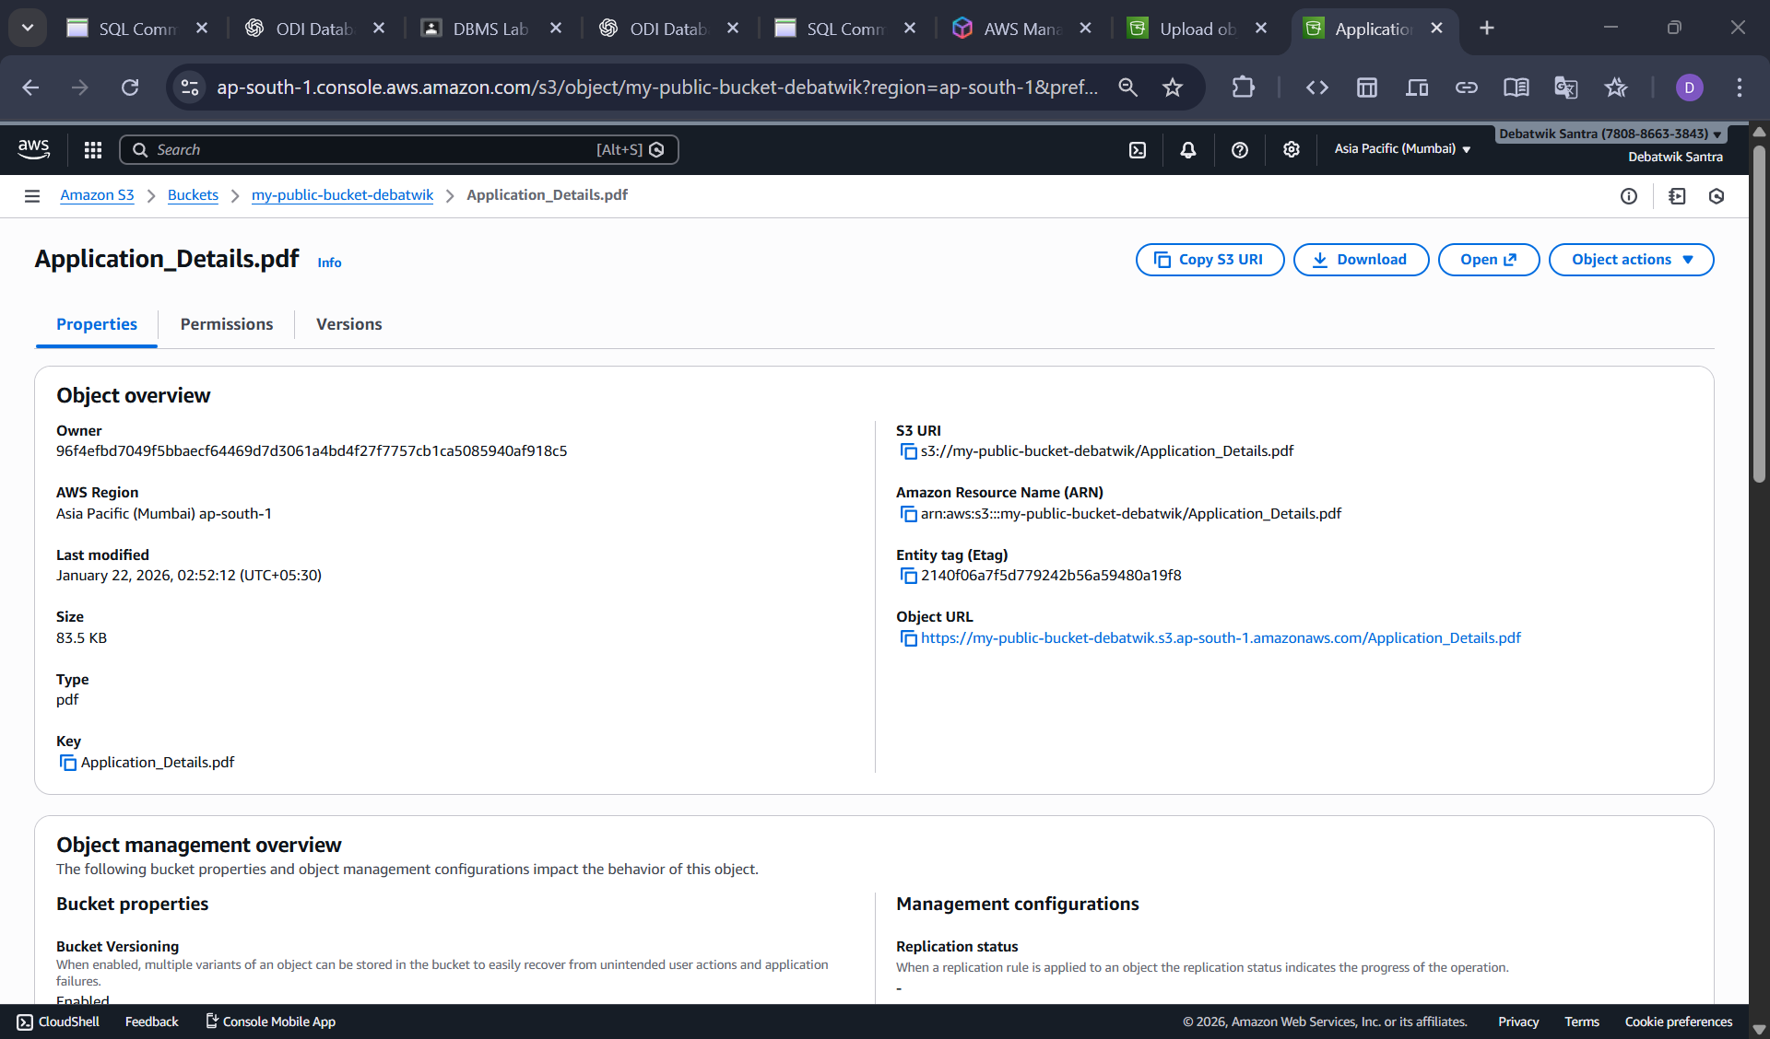

- Navigate on a new window and paste this URL. An error appears indicating that access to the contents is restricted.
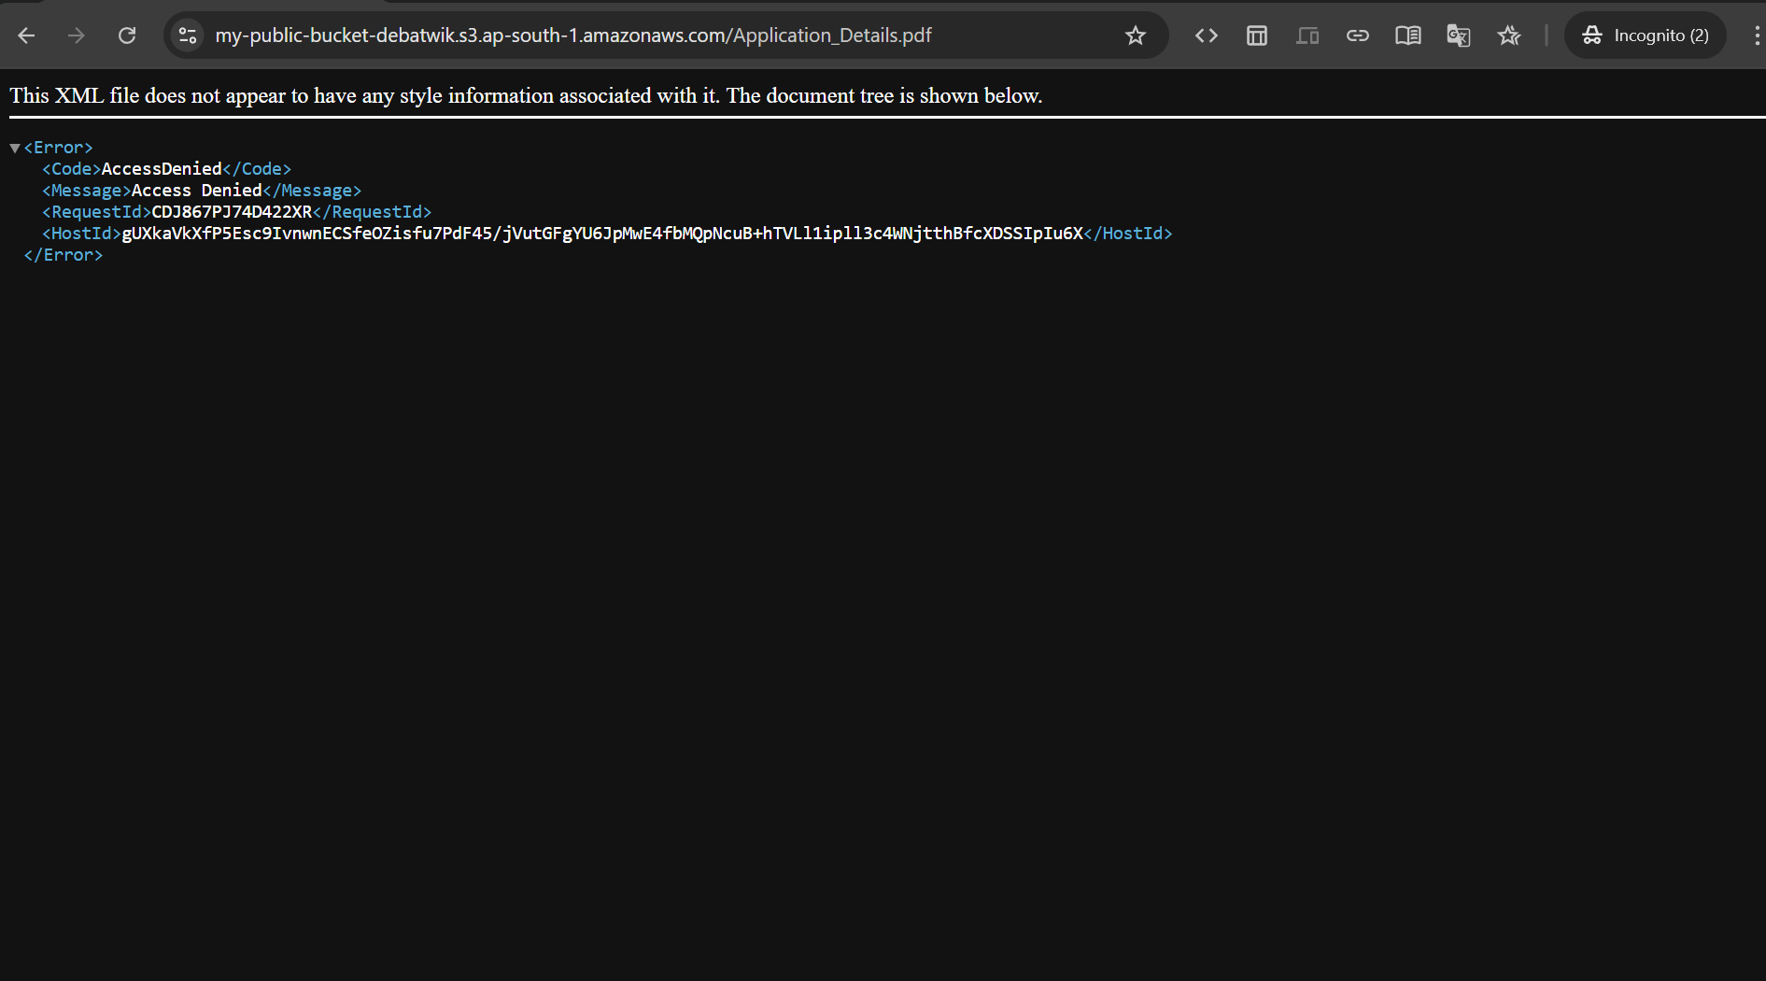
Step 4 : Make File Public
- Click on the uploaded file and Go to Permissions tab. And scroll to Object Ownership / Access Control List (ACL). and Click on the Edit.
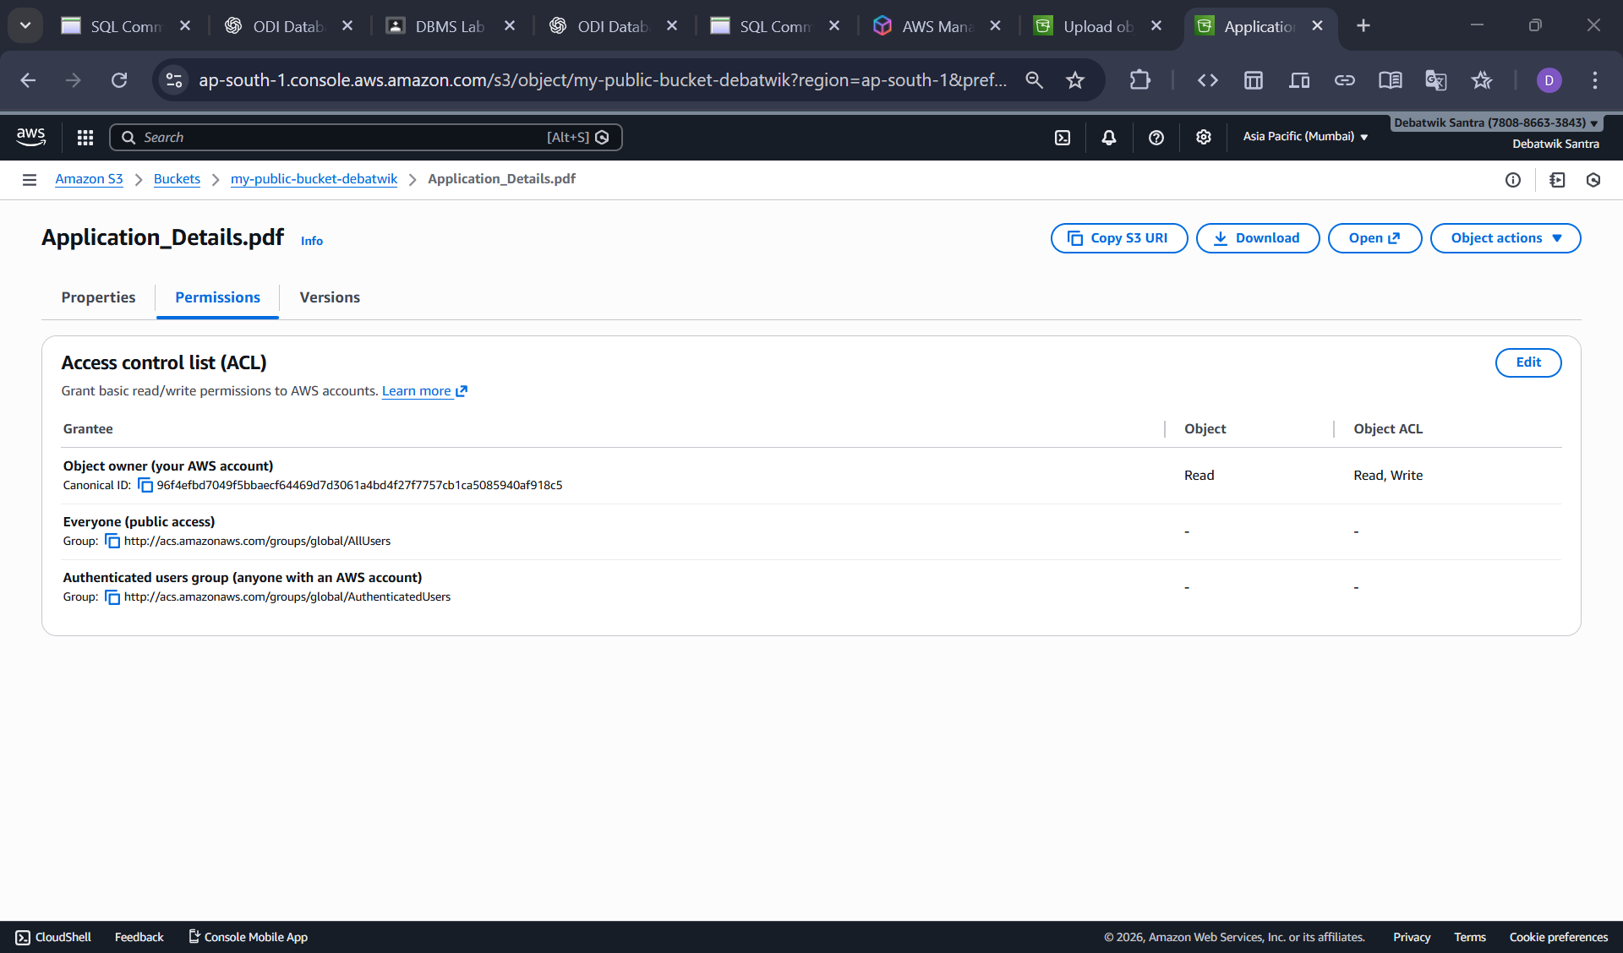
- Under Public access, check Read for Everyone (Public access) and Save Changes.
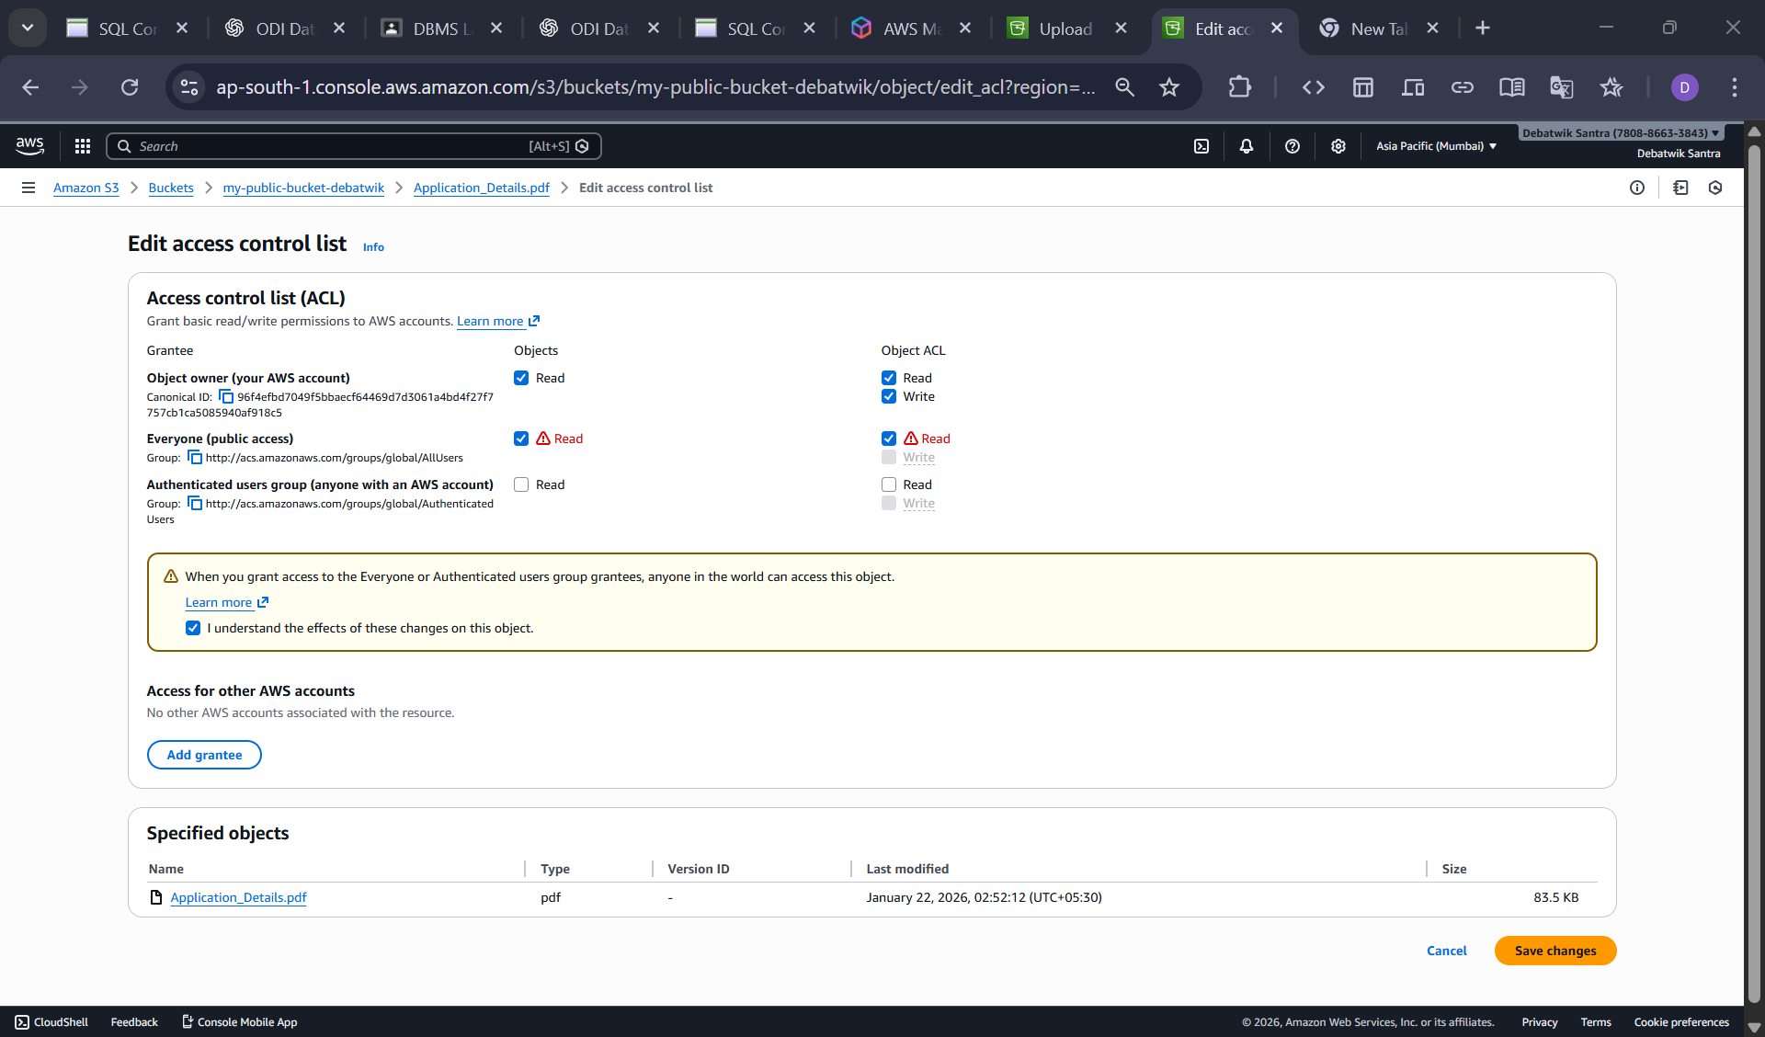
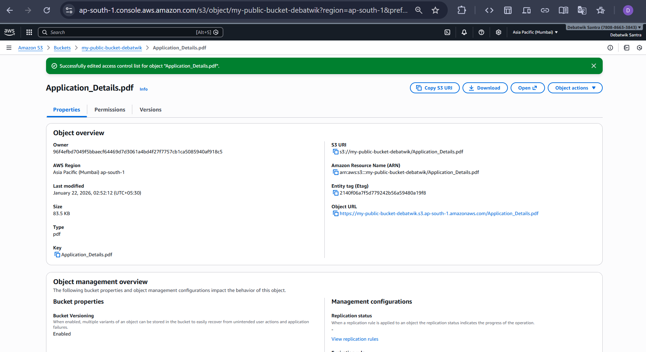
Step 5 : Verify File URL
Open the File then Copy the Object URL and then Paste URL in a New browser tab and verify the file opens without login.

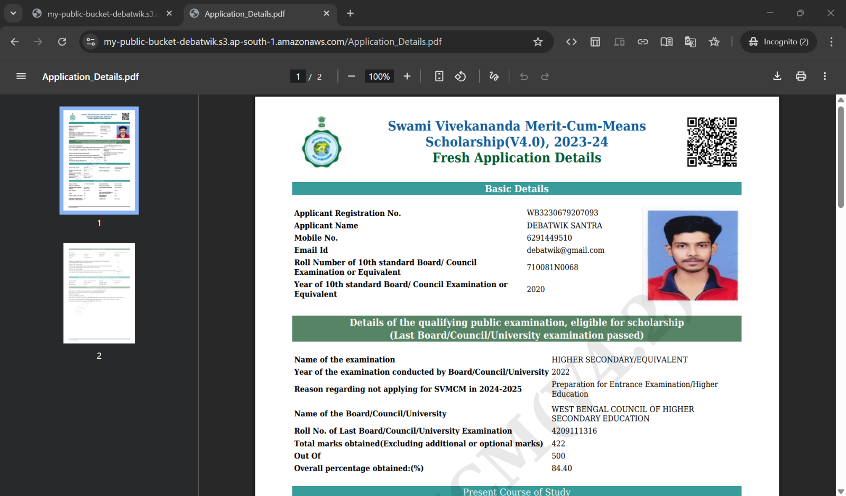
A Public S3 bucket was created , a file was uploaded, and public access was successfully verified using the object URL.

